**MAIN PAGE:**

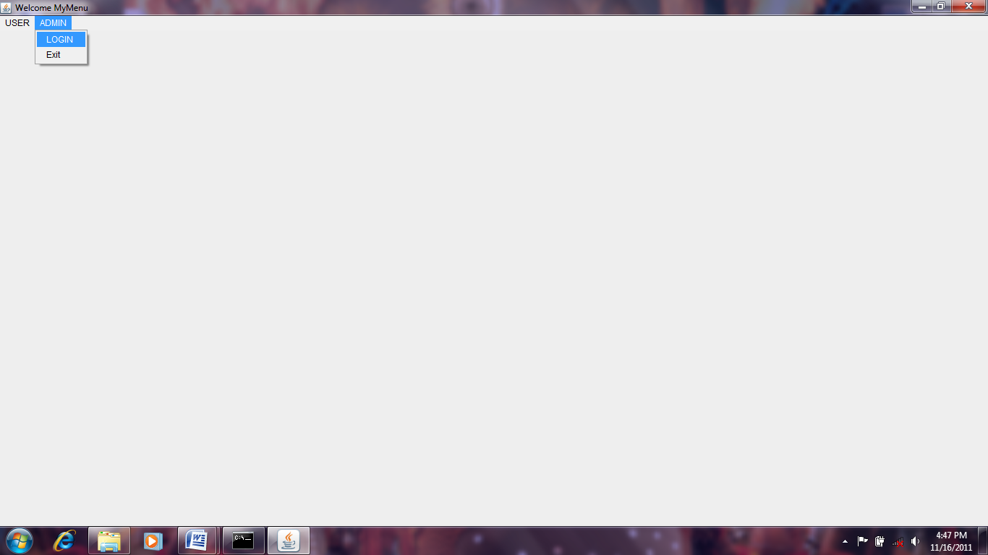

**LOGIN PAGE:**

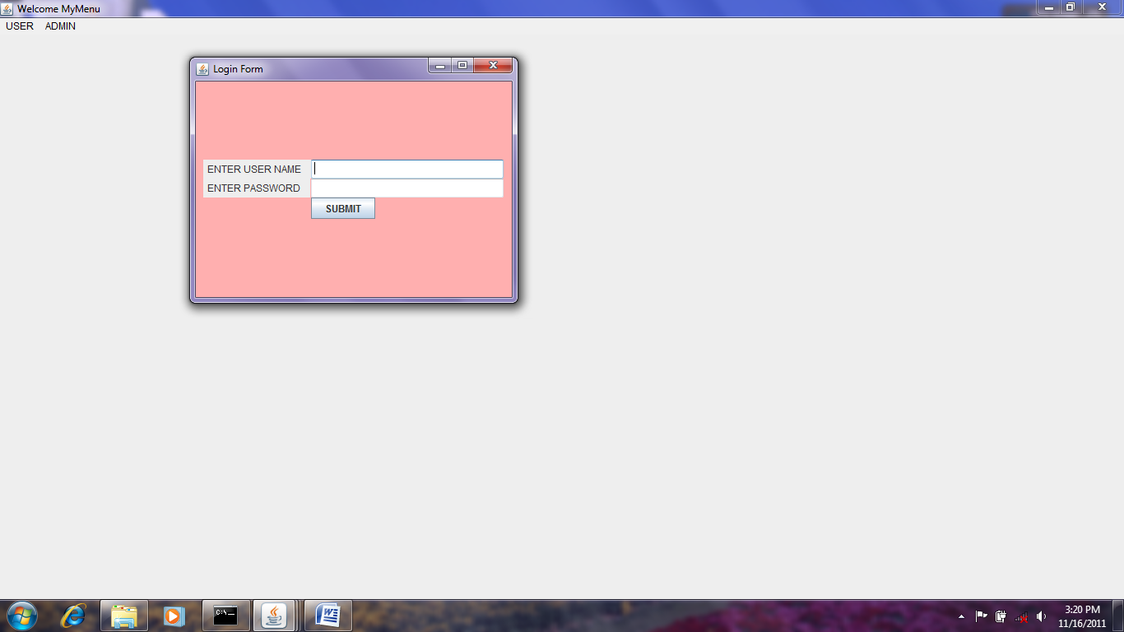

**REGISTATION PAGE**

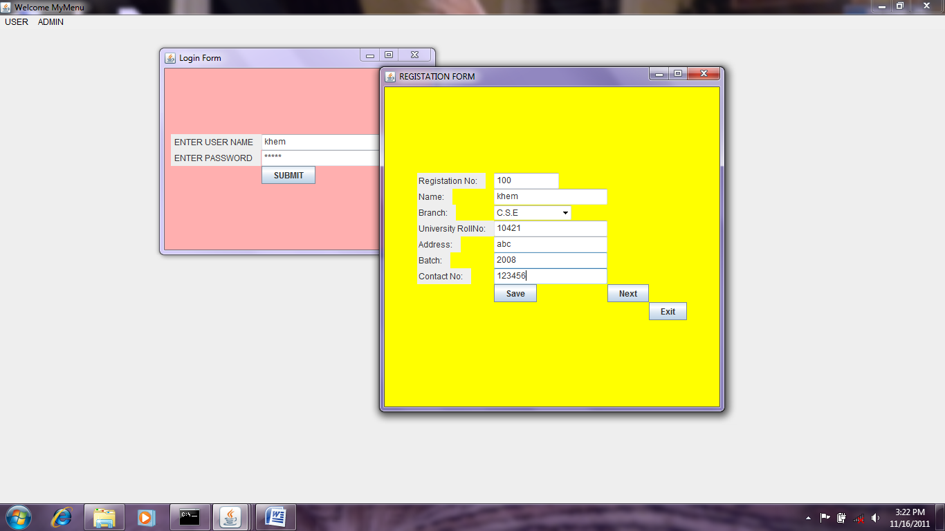

**RESULT PAGE**

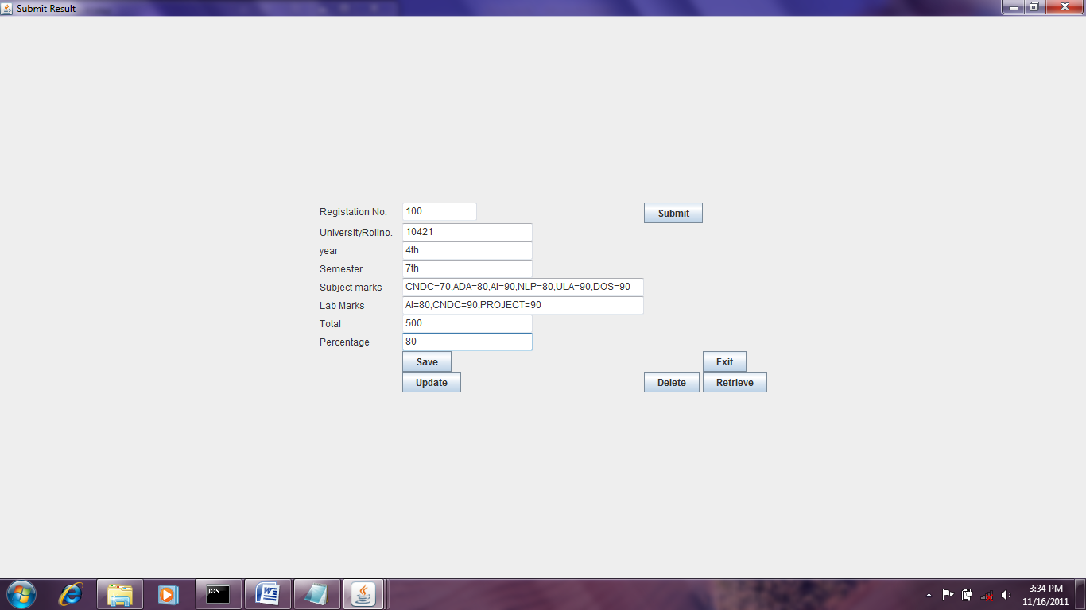

**FOR USER:**

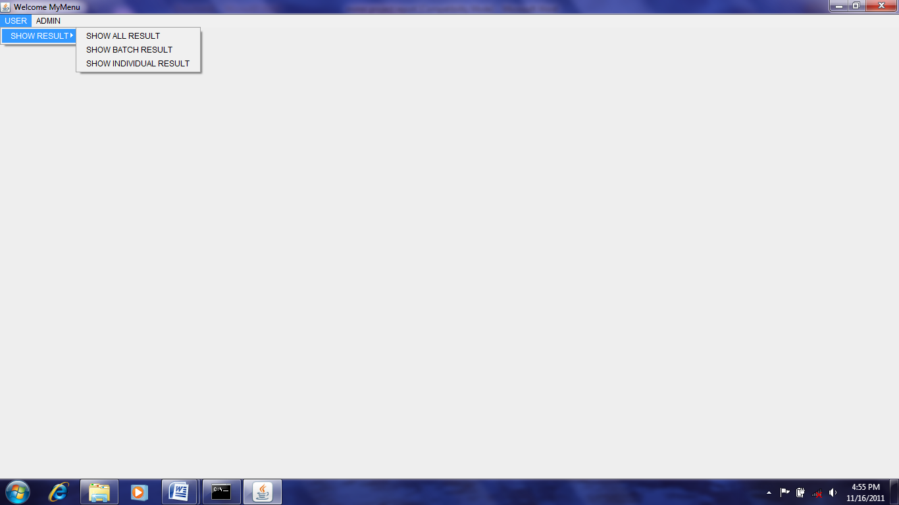

**SHOW BRANCH RESULT:**

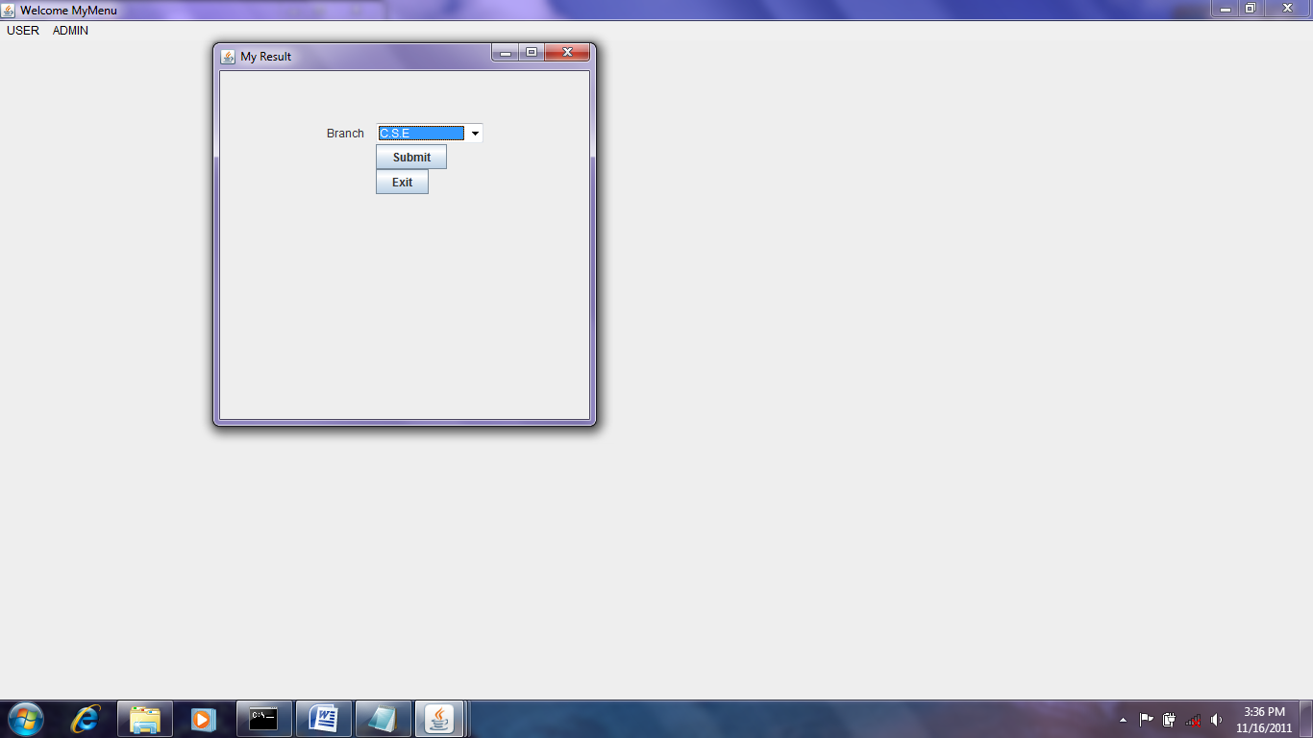

**SHOW INDIVISUAL RESULT:**

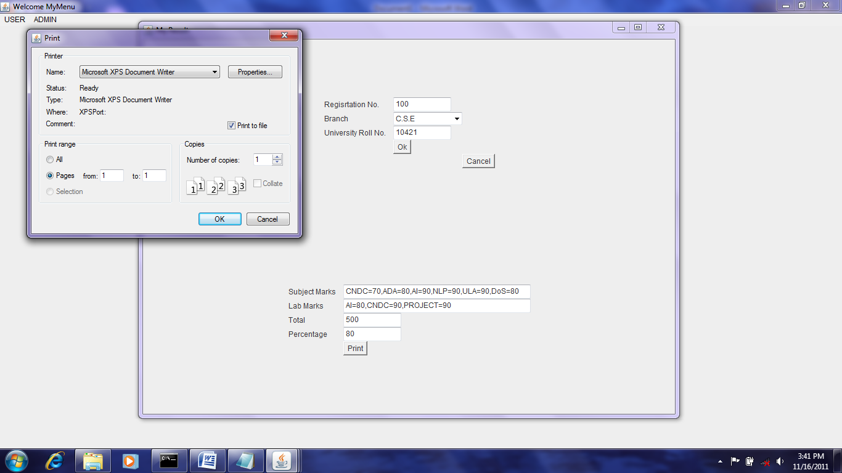

**Login page**

importjava.sql.*;

importjava.awt.*;

importjavax.swing.*;

importjava.awt.event.*;

public class Login implements ActionListener

{

JFrame f;

Panel p;

Label l1,l2;

TextField tf1,tf2;

JButton b1,b2;

GridBagLayoutgbl;

GridBagConstraintsgbc;

public Login()

{

f=new JFrame("Login Form");

p=new Panel();

tf1=new TextField(30);

tf2=new TextField(30);

tf2.setEchoChar('*');

b1=new JButton("SUBMIT");

b2=new JButton("Exit");

l1=new Label(" ENTER USER NAME");

l2=new Label(" ENTER PASSWORD");

f.add(p);

gbl=new GridBagLayout();

gbc=new GridBagConstraints();

p.setLayout(gbl);

gbc.anchor= GridBagConstraints.WEST;

gbc.gridx=1;

gbc.gridy=1;

gbl.setConstraints(l1,gbc);

p.add(l1);

gbc.gridx=3;

gbc.gridy=1;

gbl.setConstraints(tf1,gbc);

p.add(tf1);

gbc.gridx=1;

gbc.gridy=2;

gbl.setConstraints(l2,gbc);

p.add(l2);

gbc.gridx=3;

gbc.gridy=2;

gbl.setConstraints(tf2,gbc);

p.add(tf2);

gbc.gridx=3;

gbc.gridy=6;

gbl.setConstraints(b1,gbc);

p.add(b1);

b1.addActionListener(this);

f.setVisible(true);

f.setSize(400,300);

p.setBackground(Color.pink);

}

public void actionPerformed(ActionEvent e)

{

Object obj=e.getSource();

if(obj==b1)

{

try

{

Class.forName("sun.jdbc.odbc.JdbcOdbcDriver");

Connection co;

co=DriverManager.getConnection("jdbc:odbc:khem","sa","");

PreparedStatementstmt;

stmt=co.prepareStatement("select * from Login where username=? anduserpassword=?");

stmt.setString(1,tf1.getText());

stmt.setString(2,tf2.getText());

ResultSetrs=stmt.executeQuery();

if(rs.next())

{

Registationrg=new Registation();

}

else

{

JOptionPane.showMessageDialog(null,"Incorrect login or password","Error",JOptionPane.ERROR_MESSAGE);

}

}

catch(Exception ex1)

{

System.out.println(e);

}

}

}

**2.MYMENU PAGE**

importjava.sql.*;

importjava.awt.*;

importjavax.swing.*;

importjava.awt.event.*;

public class MyMenu implements ActionListener

{

JFrame f;

//Panel p;

MenuBarmb;

Menu us, ad,sh;

MenuItemlg,erf,sar,sbr,sir;

publicMyMenu()

{

f=new JFrame("Welcome MyMenu");

mb=new MenuBar();

us= new Menu("USER");

ad =new Menu("ADMIN");

sh=new Menu("SHOW RESULT");

lg=new MenuItem("LOGIN ");

erf =new MenuItem("Exit");

sar=new MenuItem("SHOW ALL RESULT");

sbr=new MenuItem("SHOW BATCH RESULT");

sir=new MenuItem("SHOW INDIVIDUAL RESULT");

**Registation:**

importjava.awt.*;

importjava.sql.*;

importjavax. swing.*;

importjava.awt.event.*;

public class Registation implements ActionListener

{

JFrame f;

Panel p;

Label l1,l2,l3,l4,l5,l6,l7;

TextField t1,t2,t4,t5,t6,t7;

JButton b1,b2,b3;

Choice ch;

GridBagLayoutgbl;

GridBagConstraintsgbc;

publicRegistation()

{

f=new JFrame("REGISTATION FORM");

p=new Panel();

l1=new Label("Registation No:");

l2=new Label("Name:");

l3=new Label("Branch:");

l4=new Label("University RollNo:");

l5=new Label("Address:");

l6=new Label("Batch:");

l7=new Label("Contact No:");

t1=new TextField(10);

t2=new TextField(20);

t4=new TextField(20);

t5=new TextField(20);

t6=new TextField(20);

t7=new TextField(20);

ch=new Choice();

ch.addItem("---Select One---");

ch.addItem("C.S.E");

ch.addItem("M.E");

ch.addItem("E.C.E");

ch.addItem("E.E.E");

ch.addItem("C.E");

b1=new JButton("Save");

b2=new JButton("Next");

b3=new JButton("Exit");

gbl=new GridBagLayout();

gbc=new GridBagConstraints();

f.add(p);

p.setLayout(gbl);

gbc.anchor=GridBagConstraints.NORTHWEST;

gbc.gridx=1;

gbc.gridy=1;

gbl.setConstraints(l1,gbc);

p.add(l1);

gbc.gridx=4;

gbc.gridy=1;

gbl.setConstraints(t1,gbc);

p.add(t1);

gbc.gridx=1;

gbc.gridy=3;

gbl.setConstraints(l2,gbc);

p.add(l2);

gbc.gridx=4;

gbc.gridy=3;

gbl.setConstraints(t2,gbc);

p.add(t2);

gbc.gridx=1;

gbc.gridy=5;

gbl.setConstraints(l3,gbc);

p.add(l3);

gbc.gridx=4;

gbc.gridy=5;

gbl.setConstraints(ch,gbc);

p.add(ch);

gbc.gridx=1;

gbc.gridy=7;

gbl.setConstraints(l4,gbc);

p.add(l4);

gbc.gridx=4;

gbc.gridy=7;

gbl.setConstraints(t4,gbc);

p.add(t4);

gbc.gridx=1;

gbc.gridy=9;

gbl.setConstraints(l5,gbc);

p.add(l5);

gbc.gridx=4;

gbc.gridy=9;

gbl.setConstraints(t5,gbc);

p.add(t5);

gbc.gridx=1;

gbc.gridy=11;

gbl.setConstraints(l6,gbc);

p.add(l6);

gbc.gridx=4;

gbc.gridy=11;

gbl.setConstraints(t6,gbc);

p.add(t6);

gbc.gridx=1;

gbc.gridy=13;

gbl.setConstraints(l7,gbc);

p.add(l7);

gbc.gridx=4;

gbc.gridy=13;

gbl.setConstraints(t7,gbc);

p.add(t7);

gbc.gridx=4;

gbc.gridy=21;

gbl.setConstraints(b1,gbc);

b1.addActionListener(this);

p.add(b1);

gbc.gridx=6;

gbc.gridy=21;

gbl.setConstraints(b2,gbc);

b1.addActionListener(this);

p.add(b2);

b2.addActionListener(this);

gbc.gridx=8;

gbc.gridy=23;

gbl.setConstraints(b3,gbc);

b1.addActionListener(this);

p.add(b3);

b3.addActionListener(this);

f.add(p);

f.setVisible(true);

f.setSize(500,500);

p.setBackground(Color.yellow);

}

public void actionPerformed(ActionEvent e)

{

Object obj=e.getSource();

if (obj==b1)

{

Save();

}

if(obj==b2)

{

Result re=new Result();

}

else if(obj==b3)

{

f.dispose();

MyMenumn = new MyMenu();

}

}

public void Save()

{

try

{

Class.forName("sun.jdbc.odbc.JdbcOdbcDriver");

Connection co=DriverManager.getConnection("jdbc:odbc:khem","sa","");

PreparedStatementstmt=co.prepareStatement("insert into Registation values(?,?,?,?,?,?,? )");

stmt.setString(1,t1.getText());

stmt.setString(2,t2.getText());

stmt.setString(3,ch.getSelectedItem());

stmt.setString(4,t4.getText());

stmt.setString(5,t5.getText());

stmt.setString(6,t6.getText());

stmt.setString(7,t7.getText());

stmt.executeUpdate();

JOptionPane.showMessageDialog(null,"value is Saved successfully");

}

catch(Exception ex1)

{

System.out.println("error found"+ex1);

}

}

public static void main(String arg[])

{

Registationrg=new Registation();

}

}

**RESULTPAGE**

importjava.awt.*;

importjava.sql.*;

importjava.awt.event.*;

importjavax.swing.*;

public class Result implements ActionListener

{

JFrame f;

Panel p;

Label l1,l2,l3,l4,l5,l6,l7,l8;

TextField t1,t2,t3,t4,t5,t6,t7,t8;

JButton b1,b2,b3,b4,b5,;

GridBagLayoutgbl;

GridBagConstraintsgbc;

public Result()

{

f=new JFrame("Submit Result");

p=new Panel();

l1=new Label("Registation No.");

l2=new Label("UniversityRollno.");

l3=new Label("year");

l4=new Label("Semester");

l5=new Label("Subject marks");

l6=new Label("Lab Marks");

l7=new Label("Total");

l8=new Label("Percentage");

t1=new TextField(10);

t2=new TextField(20);

t3=new TextField(20);

t4=new TextField(20);

t5=new TextField(40);

t6=new TextField(40);

t7=new TextField(20);

t8=new TextField(20);

b1=new JButton("Save");

b2=new JButton("Exit");

b3=new JButton("Submit");

b4=new JButton ("Update");

b5=new JButton ("Delete");

gbl=new GridBagLayout();

gbc=new GridBagConstraints();

f.add(p);

p.setLayout(gbl);

gbc.anchor=GridBagConstraints.NORTHWEST;

gbc.gridx=1;

gbc.gridy=1;

gbl.setConstraints(l1,gbc);

p.add(l1);

gbc.gridx=4;

gbc.gridy=1;

gbl.setConstraints(t1,gbc);

p.add(t1);

gbc.gridx=1;

gbc.gridy=3;

gbl.setConstraints(l2,gbc);

p.add(l2);

gbc.gridx=4;

gbc.gridy=3;

gbl.setConstraints(t2,gbc);

p.add(t2);

gbc.gridx=1;

gbc.gridy=5;

gbl.setConstraints(l3,gbc);

p.add(l3);

gbc.gridx=4;

gbc.gridy=5;

gbl.setConstraints(t3,gbc);

p.add(t3);

gbc.gridx=1;

gbc.gridy=7;

gbl.setConstraints(l4,gbc);

p.add(l4);

gbc.gridx=4;

gbc.gridy=7;

gbl.setConstraints(t4,gbc);

p.add(t4);

gbc.gridx=1;

gbc.gridy=9;

gbl.setConstraints(l5,gbc);

p.add(l5);

gbc.gridx=4;

gbc.gridy=9;

gbl.setConstraints(t5,gbc);

p.add(t5);

gbc.gridx=1;

gbc.gridy=11;

gbl.setConstraints(l6,gbc);

p.add(l6);

gbc.gridx=4;

gbc.gridy=11;

gbl.setConstraints(t6,gbc);

p.add(t6);

gbc.gridx=1;

gbc.gridy=13;

gbl.setConstraints(l7,gbc);

p.add(l7);

gbc.gridx=4;

gbc.gridy=13;

gbl.setConstraints(t7,gbc);

p.add(t7);

gbc.gridx=1;

gbc.gridy=15;

gbl.setConstraints(l8,gbc);

p.add(l8);

gbc.gridx=4;

gbc.gridy=15;

gbl.setConstraints(t8,gbc);

p.add(t8);

gbc.gridx=4;

gbc.gridy=21;

gbl.setConstraints(b1,gbc);

p.add(b1);

b1.addActionListener(this);

gbc.gridx=6;

gbc.gridy=21;

gbl.setConstraints(b2,gbc);

p.add(b2);

b2.addActionListener(this);

gbc.gridx=5;

gbc.gridy=1;

gbl.setConstraints(b3,gbc);

p.add(b3);

b3.addActionListener(this);

gbc.gridx=4;

gbc.gridy=22;

gbl.setConstraints(b4,gbc);

b4.addActionListener(this);

p.add(b4);

gbc.gridx=5;

gbc.gridy=22;

gbl.setConstraints(b5,gbc);

b5.addActionListener(this);

p.add(b5);

f.add(p);

t2.enable(true);

t3.enable(true);

t4.enable(true);

t6.enable(true);

f.setVisible(true);

f.setSize(600,600);

}

public void actionPerformed(ActionEvent e)

{

Object obj=e.getSource();

if (obj==b1)

{

Save();

}

if(obj==b2)

{

f.setVisible(false);

}

if(obj==b3)

{

Submit();

}

if(obj==b4)

{

update();

}

if (obj==b5)

{

delete();

}

}

public void Save()

{

try

{

Class.forName("sun.jdbc.odbc.JdbcOdbcDriver");

Connection co=DriverManager.getConnection("jdbc:odbc:khem","sa","");

PreparedStatementstmt=co.prepareStatement("insert into Result values(?,?,?,?,?,?,?,? )");

stmt.setString(1,t1.getText());

stmt.setString(2,t2.getText());

stmt.setString(3,t3.getText());

stmt.setString(4,t4.getText());

stmt.setString(5,t5.getText());

stmt.setString(6,t6.getText());

stmt.setString(7,t7.getText());

stmt.setString(8,t8.getText());

stmt.executeUpdate();

//System.out.println ("Value Saved successfully");

JOptionPane.showMessageDialog(null,"value is Saved successfully");

t1.setText("");

t2.setText("");

t3.setText("");

t4.setText("");

t5.setText("");

t6.setText("");

t7.setText("");

t8.setText("");

}

catch(Exception ex1)

{

System.out.println("error found"+ex1);

}

}

public void Submit()

{

System.out.print(("hello"));

try

{

Class.forName("sun.jdbc.odbc.JdbcOdbcDriver");

Connection co=DriverManager.getConnection("jdbc:odbc:khem","sa","");

Statement Stat=co.createStatement();

ResultSetrs;

rs=Stat.executeQuery("Select * from Registation where sturegstation_no='"+t1.getText()+"' ");

t1.setText("");

rs.next();

t1.setText(rs.getString(1));

t2.setText(rs.getString(2));

t3.setText(rs.getString(3));

t4.setText(rs.getString(4));

}

catch(Exception ex1)

{

System.out.println("error found"+ex1);

}

}

public void delete()

{

try

{

Class.forName("sun.jdbc.odbc.JdbcOdbcDriver");

Connection co=DriverManager.getConnection("jdbc:odbc:khem","sa","");

PreparedStatementstmt=co.prepareStatement("Delete from Result where sturegistation_no=? ");

stmt.setString(1,t1.getText());

stmt.executeUpdate();

//System.out.println ("Value Deleted successfully");

JOptionPane.showMessageDialog(null,"value is Deleted successfully");

t1.setText("");

t2.setText("");

t3.setText("");

t4.setText("");

t5.setText("");

t6.setText("");

t7.setText("");

t8.setText("");

}

catch(Exception ex1)

{

System.out.println("error found"+ex1);

}

}

public void update()

{

try

{

Class.forName("sun.jdbc.odbc.JdbcOdbcDriver");

Connection co=DriverManager.getConnection("jdbc:odbc:khem","sa","");

PreparedStatementstmt=co.prepareStatement("Update Result set stubatch=?,stusemester=?,stusubject_marks=?,stuLab_marks=?,stutotal=?,stupercentage=?,stuu

**SHOWBRANCH**

importjavax.swing.*;

importjavax.swing.table.*;

importjava.awt.*;

importjava.util.Vector;

importjava.sql.*;

public class ShowBranch {

String username = "sa";

String password = "";

String Database = "jdbc:odbc:proj";

Connection Conn;

JFrame f;

ShowBranch(String str23)

{

try

{

f = new JFrame("menu");

f.setSize(400,300);

f.setLocation(200,100);

f.setTitle("Stock Report");

JPaneljPanel = new JPanel( new BorderLayout() );

Conn = DriverManager.getConnection( Database, username, password );

System.out.println("*** Connect to the database ***");

//Access Rows and Columns from database

Vector<String> Columns = new Vector<String>();

Vector<Vector<Object>> Rows = new Vector<Vector<Object>>();

String Query = "Select * from setresult where stuBranch='"+str23+"'";

Statement smnt = Conn.createStatement();

ResultSet results = smnt.executeQuery( Query );

ResultSetMetaDatametaDt = results.getMetaData();

int cols = metaDt.getColumnCount();

Columns.clear(); // clear unwanted value if exist any in Columns variable.

//Get Columns From database

for (int i = 1; i <= cols; i++)

{

Columns.addElement(metaDt.getColumnName(i));

}

Rows.clear(); // clear unwanted value if exist any in Rows variable.

//Get RowsNames From database

while(results.next())

{

Vector<Object> row = new Vector<Object>(cols);

for (int i = 1; i <= cols; i++)

{

row.addElement(results.getObject(i));

}

Rows.addElement(row);

}

results.close(); //close Resultset.

smnt.close(); //close Statement.

//Define TableModel

TableModeltmodel = new DefaultTableModel(Rows, Columns){ };

// JTable Creation

JTable Table = new JTable(tmodel);

JScrollPane scroll = new JScrollPane(Table);

jPanel.add(scroll);

f.add(jPanel, BorderLayout.CENTER);

f.setVisible(true);

Conn.commit();

Conn.close(); //Close Connection to the database

}

catch(Exception e)

{

}

}

}

**SHOW INDIVSUAL RESULT**

importjava.awt.*;

importjava.awt.event.*;

import java.sql.*;

importjavax.swing.*;

importjava.awt.print.*;

public class ShowEnggResult implements ActionListener,Printable

{

JFrame f;

Panel p,p1;

Label l2,l3,l4,l5,l6,l7,l8;

TextField t2,t4,t5,t6,t7,t8;

Choice ch;

Button b1,b2,b3;

GridBagLayoutgbl;

GridBagConstraintsgbc;

GridLayoutgl;

publicShowEnggResult()

{

f=new JFrame("My Result");

p=new Panel();

p1=new Panel();

l2=new Label("Regisrtation No.");

l3=new Label("Branch");

l4=new Label("University Roll No.");

l5=new Label("Subject Marks");

l6=new Label("Lab Marks");

l7=new Label("Total");

l8=new Label("Percentage");

t2=new TextField(10);

t4=new TextField(10);

t5=new TextField(40);

t6=new TextField(40);

t7=new TextField(10);

t8=new TextField(10);

ch=new Choice();

ch.addItem("---Select One---");

ch.addItem("C.S.E");

ch.addItem("M.E");

ch.addItem("E.C.E");

ch.addItem("E.E.E");

ch.addItem("C.E");

b1=new Button("Ok");

b2=new Button("Cancel");

b3=new Button("Print");

gbl=new GridBagLayout();

gbc=new GridBagConstraints();

gl=new GridLayout(2,1);

f.setLayout(gl);

p.setLayout(gbl);

p1.setLayout(gbl);

gbc.anchor=GridBagConstraints.NORTHWEST;

gbc.gridx=1;

gbc.gridy=3;

gbl.setConstraints(l2,gbc);

p.add(l2);

gbc.gridx=4;

gbc.gridy=3;

gbl.setConstraints(t2,gbc);

p.add(t2);

gbc.gridx=1;

gbc.gridy=5;

gbl.setConstraints(l3,gbc);

p.add(l3);

gbc.gridx=4;

gbc.gridy=5;

gbl.setConstraints(ch,gbc);

p.add(ch);

gbc.gridx=1;

gbc.gridy=7;

gbl.setConstraints(l4,gbc);

p.add(l4);

gbc.gridx=4;

gbc.gridy=7;

gbl.setConstraints(t4,gbc);

p.add(t4);

gbc.gridx=1;

gbc.gridy=9;

gbl.setConstraints(l5,gbc);

p1.add(l5);

gbc.gridx=4;

gbc.gridy=9;

gbl.setConstraints(t5,gbc);

p1.add(t5);

gbc.gridx=1;

gbc.gridy=11;

gbl.setConstraints(l6,gbc);

p1.add(l6);

gbc.gridx=4;

gbc.gridy=11;

gbl.setConstraints(t6,gbc);

p1.add(t6);

gbc.gridx=1;

gbc.gridy=13;

gbl.setConstraints(l7,gbc);

p1.add(l7);

gbc.gridx=4;

gbc.gridy=13;

gbl.setConstraints(t7,gbc);

p1.add(t7);

gbc.gridx=1;

gbc.gridy=15;

gbl.setConstraints(l8,gbc);

p1.add(l8);

gbc.gridx=4;

gbc.gridy=15;

gbl.setConstraints(t8,gbc);

p1.add(t8);

gbc.gridx=4;

gbc.gridy=19;

gbl.setConstraints(b1,gbc);

p.add(b1);

b1.addActionListener(this);

gbc.gridx=7;

gbc.gridy=21;

gbl.setConstraints(b2,gbc);

p.add(b2);

b2.addActionListener(this);

gbc.gridx=4;

gbc.gridy=23;

gbl.setConstraints(b3,gbc);

p1.add(b3);

b3.addActionListener(this);

f.add(p);

f.add(p1);

f.setVisible(true);

f.setLocation(300,300);

f.setSize(600,600);

}

public void actionPerformed(ActionEvent e) {

Object obj= e.getSource();

if(obj==b1)

{

try

{

Class.forName("sun.jdbc.odbc.JdbcOdbcDriver");

Connection co=DriverManager.getConnection("jdbc:odbc:khem","sa","");

Statement Stat=co.createStatement();

ResultSetrs;

rs=Stat.executeQuery("Select * from Result where sturegistation_no='"+t2.getText()+"'and stuBranch='"+ch.getSelectedItem()+"'and stuuniversityroll_no='"+t4.getText()+"'");

rs.next();

t5.setText(rs.getString(5));

t6.setText(rs.getString(6));

t7.setText(rs.getString(7));

//t8.setText(rs.getstring(8));

}

catch(Exception ex1)

{

System.out.println("error found"+ex1);

}

}

else if (obj == b2)

{

f.dispose();

}

else if (obj ==b3 )

{

PrinterJob job = PrinterJob.getPrinterJob();

job.setPrintable(this);

boolean ok = job.printDialog();

if (ok) {

try {

job.print();

} catch (PrinterException ex) {

/* The job did not successfully complete */

}

}

}

}

publicint print(Graphics g, PageFormatpf, int page) throws

PrinterException {

if (page > 0) {

return NO_SUCH_PAGE;

}

Graphics2D g2d = (Graphics2D)g;

g2d.translate(pf.getImageableX(), pf.getImageableY());

String str10 ="ENGINEERING STUDENT RESULT";

String str11 = "===========================";

String str12 = "Registration No. "+t2.getText();

String str13= "Branch " +ch.getSelectedItem();

String str14 = "University RollNO " +t4 .getText();

String str15 = "Subject Marks "+t5.getText();

String str16 = "Lab Marks "+t6.getText();

String str17= "Total "+t7.getText();

String str18 = "Percentage "+t8.getText()+"%";

g.drawString(str11,175,200);

g.drawString(str10,175,205);

g.drawString(str12,150,230);

g.drawString(str13,150,260);

g.drawString(str14,150,290);

g.drawString(str15,150,320);

g.drawString(str16,150,350);

g.drawString(str17,150,380);

return PAGE_EXISTS;

}

public static void main(String args[])

{

ShowEnggResultsher=new ShowEnggResult();

}

}

**Data base**

create database proj

useproj

create table login

(id

stuuser_namevarchar(20),

stu_passwordvarchar(20),

)

useproj

create table Registation

(

sturegistation_novarchar(20),

stunamevarchar(20),

stubranchvarchar(10),

stuuniversity_roll_novarchar(10),

stuaddress char(50),

stubatchvarchar(10),

stucontect_novarchar(15),

)

useproj

create table Result

(

sturegistation_novarchar(20),

stuuniversityrllo_novarchar(20),

stubranchvarchar(20),

stuyearvarchar(20),

stusemestervarchar(20),

stusub_marksvarchar(200),

stulab_marksvarchar(200),

stutotalvarchar(200),

stupercentagevarchar(100),

)

select *from Registation

insert into login values('khem','mgiet')

useproj

drop table Result